Project Design Phase
Solution Architecture
Date | 19 July 2026
Team ID | (Assign as per SmartBridge Portal)
Project Name | Strategic Product Placement & Business Intelligence Suite
Team Members | Vishnu Edara (Team Lead)  Rama Krishna Siripurapu  Sravanthi Nagelli  Liven Tulugu  Jaya Veera Chaitanya Vuyyuru
Maximum Marks | 4 Marks

Solution architecture bridges the gap between the merchandising business problem and the technology solution. It identifies the best-fit technologies, describes system structure and behavior, and defines the components, phases and requirements needed to deliver the Strategic Product Placement & Business Intelligence Suite.
Solution Architecture Diagram
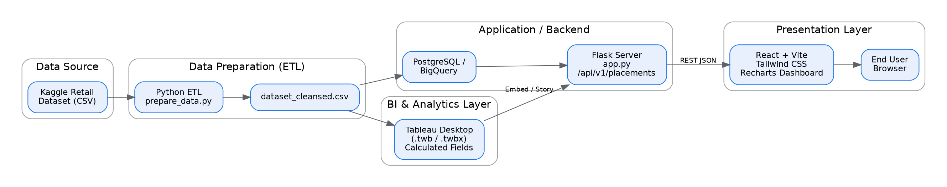
Figure 1: Architecture and data flow of the Strategic Product Placement BI Suite — from the raw Kaggle dataset through the Python ETL pipeline, Tableau analytical layer, Flask REST API, and React presentation layer to the end user.
Architecture Layer Summary
Layer | Responsibility
Data Source | Kaggle retail placement dataset (dataset.csv) with pricing, position, traffic, demographics and sales fields.
Data Preparation (ETL) | prepare_data.py strips whitespace, imputes missing values, suppresses outliers and pre-compiles Gross Revenue, Unit Cost and Profit into dataset_cleansed.csv.
BI & Analytics | Tableau Desktop workbook (.twb/.twbx) hosts 5 calculated fields and 4 analytical worksheets, plus the 5-scene storyboard and executive dashboard.
Application / Backend | Flask server (app.py) exposes /api/v1/placements as JSON; PostgreSQL/BigQuery persist and scale the underlying data.
Presentation Layer | React 19 + Vite + Tailwind CSS + Recharts render the responsive dashboard consumed by category managers and analysts in the browser.

